## Yaw

For left turn, rotors rotating in clockwise direction are rotated faster than anticlockwise rotors, generating definite angular momentum in downward direction but since there is no net toque acting on the system (torque about cg due to aerodynamic forces on rotors is negligible), whole body of the quad-rotor tend to rotate in anticlockwise direction in order to conserve angular momentum (this rotation generates angular momentum in upward direction and cancels the downward angular momentum generated by rotors).  Similarly for right turn.

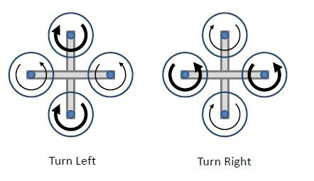

Figure 3.f: Yaw (Bold arrow represents higher RPM)